Megha Dhawan

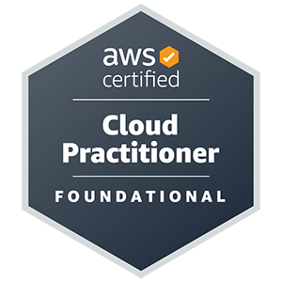 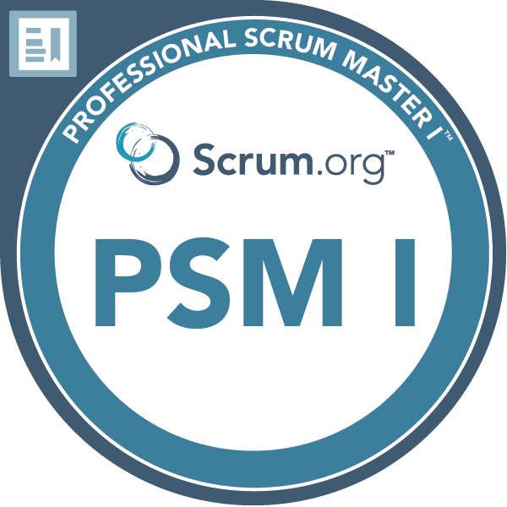

**Address** : 71 Oakway, Northgate, Crawley, WSX RH108HY

**Phone** : 07404529668, +447404529668

**Email** : [megha29dhawan@gmail.com](mailto:megha29dhawan@gmail.com)

**Microsoft Azure, ITIL & Scrum** Certified highly skilled Application Support and implementation Analyst with the expertise of supporting projects for multinational clients in the Finance, Insurance and Banking, E-Commerce and Airlines sectors. Complex problem solver able to thrive in fast-paced and challenging roles.

Skills

* **Cloud Computing:-** AWS, Azure
* **Database:**- Microsoft SQL Server | Oracle | MySQL
* **Operating Systems /Servers:-** Windows | iOS | UNIX | Linux | Ubuntu | Debian| Nginx
* **Languages:-** C | C++ | C# | .Net | ASP.net | Java | T/SQL | SQL | PL/SQL
* **Web Technologies:-** HTML | XML | JavaScript | CSS |
* **Monitoring Tools:-** Grafana | Kibana | PagerDuty | Splunk | SiteScope | AppDynamics | Dynatrace
* **Ticketing Tools:-** Jira | Remedy | Service Now | Zendesk
* **Documentation and Reporting:-** Office 365, MS Word, MS Excel, MS PowerPoint, Power BI
* **Networking:-** DNS, SSH, IP addressing

**Certifications**

* 2022 - Microsoft Azure Administrator Certified - AZ-104
* 2021 - Microsoft Azure Fundamental Certified - AZ-900
* 2019 - Scrum Certified
* 2015 – ITIL v3 Certified
* 2014 – Prince2 Certified
* 2007 - SharePoint 2007 Certified

Accomplishments and Awards

**Honoured with:**

* On the Spot Award for best customer experience in - 2022 (TCS)
* On the Spot Award for best customer experience in - 2019 and 2020 (TCS)
* On the Spot Award for outstanding contribution to organisation - 2017 (TCS)
* Promoted as Assistant Consultant in - 2015 (TCS)
* Service and Commitment Award - 2013 (TCS)
* On the Spot Award for Excellent work to deliver a critical change for client - 2012 (TCS)
* Service and Commitment Award – 2011 ( TCS)

Education

* 3 Years Bachelor’s Degree in Computer Engineering, 2007 with 70% (B.E)
* 3 Years Diploma in Computer Science 2003 with 72.33%
* Matriculation from Central Board of Secondary Education in 2001 with 72%

Work history

* Tata Consultancy Services, UK

**Client - Legal and General, UK**

Role – Customer Service Manager, 07/2020 to Current

**Introduction:** For over 185 years **Legal and General has provided Banking and financial services to customers across the UK**. They are now a global provider of retirement solutions to corporate and individuals, and skills lie in asset management and origination, longevity risk and technological innovation

**Profile/Responsibilities:**

* Resolving and mitigating all the production issues for **Finance application within SLA.**
* Working on finding the root causes for the reported issues and applying permanent fixes.
* **Gathering high-level technical requirements** by proposing descriptions associated with **existing product/platform capabilities** to minimise client risk and promote standardisation.
* Conducts health checks across systems to ensure optimal configuration and deployment of customer environments (e.g., products, services, features).
* Guides customers in understanding and implementing new versions of solutions.
* **Acts as a bridge between** engineering and customers during the entire lifecycle of the solution.
* Responds and resolve immediate issues using available resources throughout the solution's lifecycle.
* **Proactively offers guidance to customers for designing configurations and deploying solutions on Microsoft platforms.**
* Manages intricate escalations of customer issues from support or field teams.
* Evaluates impact to prioritize escalations and determine their urgency.
* Performs in-depth root cause analysis of problems, converting them into opportunities for improvement.
* **Serves as an escalation point** for specialized knowledge areas.
* Represents the team in addressing complex issues and addressing a wide range of technical inquiries.
* **Prepared post-incident review documents** and attended problem management review meetings to ensure root cause determination; prepared accurate, appropriate and timely communication to internal and external stakeholders.
* **Reduced Escalation Rates** implemented proactive measures that led to a reduction in escalated cases, demonstrating the ability to address issues at an earlier stage and prevent dissatisfaction.
* **Improved First-Call Resolution** implemented strategies that increased the percentage of issues resolved during the initial customer contact, minimizing the need for follow-up interactions.
* **Successfully Managed High-Volume Periods** and demonstrated effective leadership during peak seasons, ensuring that customer service operations remained smooth and customers received timely assistance.
* **Ensuring all changes are technically reviewed and assessed**, in line with L&G change management processes, and that the team represent the changes at the change approval board.
* Actively identifying risks, ensuring they are appropriately logged and tracked at the appropriate forums, and taking appropriate action to mitigate or resolve.
* **Providing support to major incidents as they occur**, and managing subsequent activities needed to prevent re-occurrence via Problem Management.
* **Collaborating with multiple stakeholders (BA’s Product Lead, DevOps and Engineering teams)** within operations and our account management groups to take feedback to better support those groups during major implementation issue
* Provided change approvals by assessing risks and impacts.
* Writing SQL data queries on SQL database to investigate customer queries.
* Creating a dashboard using Power BI, Service Now.
* **Attending Daily Cab, Sprint calls, Backlog refinement calls, Technical Cab meetings, and Demand Pipeline meetings to understand changes scheduled and planned for the** future.
* Tata Consultancy Services, UK

**Client – Legal and General**

Role – Project Manager, 06/2019 to 07/2020

Technology Used: Power BI

**Introduction:** Lead and worked on the project to create a Power BI visualization of Dashboards for Finance Department.

**Profile/Responsibilities:**

* Break the project into tasks and **converted them in stories in Jira.**
* Defining **acceptance criteria for stories.**
* Analysed business requirements and developed project deliverables accordingly.
* Managed numerous **external data sources including (SQL, Excel, & Access).**
* Setting an appropriate schedule for the development of certain deliverables.
* **Set up Sprint planning, review and retrospective meetings** to deliver the project as per the defined schedule.
* Defined milestones, and Highlighted the project dependencies.
* Conducting **Daily stand-up call** with the team to understand the work in progress, completed and blockers.
* Built relationships with the client team to quickly understand requirements and business objectives.
* Advised client stakeholders at their request on key resource changes to jumpstart project pace and ensure timely completion.
* Managed offshore development teams. Mentored and coached internal and client teams to achieve project targets.
* Designed and implemented multiple dashboards using **Power BI - PowerPivot & Power Query tools**
* Tata Consultancy Services, UK

**Client - Virgin Atlantic Airways**

Role – Sr. Problem Analyst, 05/2017 to 06/2019

**Introduction:** Virgin Atlantic, a [trading name](https://en.wikipedia.org/wiki/Trade_name) of Virgin Atlantic Airways Limited and Virgin Atlantic International Limited, is a British airline with its head office in [Crawley](https://en.wikipedia.org/wiki/Crawley), England.

**Profile/Responsibilities:**

* Identify Problem Investigation, assignment issues, **Acting as an initial escalation point for day-to-day Problem Management issues**
* Review the initial classification (includes priority) and categorization of the Problem Record
* Analysing Incidents (especially Critical Incidents) and closed Problems to identify and act upon trends Tracking open Problems and identifying any Problem that requires increased focus to meet agreed target levels
* **Able to perform Pro-active root cause analysis based on incident trends** and non-incident based triggers (ex. SLA breaches, complaints)
* Handling day-to-day Problem issues and escalating to Resolver Groups when required to ensure targets are met
* Run and Manage Numerous Problem Management related reports
* Chair problem and Incident Management review meetings in order to identify the root cause and preventative fixes as well as determine the suitability of proposed/in-place workarounds
* Work closely with the Change Management team to ensure changes have been raised to resolve problems and known errors and that the impact of changes is fully understood
* Implement a mechanism to record Known errors within the account and the associated workarounds
* Tata Consultancy Services, UK

**Client - Virgin Atlantic Airways**

Role – Technical Support Lead, 05/2014 to 05/2017

Technology Used: SQL Server 2005/ Unix/Linux/**SharePoint**

**Introduction:** Virgin Atlantic, a [trading name](https://en.wikipedia.org/wiki/Trade_name) of Virgin Atlantic Airways Limited and Virgin Atlantic International Limited, is a British airline with its head office in [Crawley](https://en.wikipedia.org/wiki/Crawley), England.

**Profile/Responsibilities:**

* Single Point of Contact (SPOC) for all communications between customers, clients and team members.
* Conducting Daily stand-up call with team to understand the work in progress, completed and blockers
* SiteScope monitoring set-up, Splunk alert/dashboard set-up
* **Writing SQL queries to resolve database issues for user reported tickets/issues.**
* Identifying, monitoring and automation opportunities and implementation
* Participating in ticketing tool enhancement and deployment (Jira, Service Now)
* Setting up call with users for requirement analysis & working with development team to lower the issues/tickets flow
* **Dealing with users/client and resolving problems**, issues and making sure SLA's are met
* Conducting regular impact analysis in order to assess the consequences of the project deliverables on other sections of the business.
* Arranging weekly application support call with client for the progress measurement, **new requirement, implement process improvements** and participating daily/weekly team meetings for targets &achievements of the ticket SLA's
* Working on achieving high standards and KPI targets; recruiting new staff members
* Resolving extract, transform, and load (ETL) procedural failures and automating ETL process by writing shell scripts.
* Setting up new alerts and dashboard in SiteScope, Splunk, Dynatrace.
* **Fostering a positive working environment within the team**
* Providing prompt and accurate information on individual performance
* Collaborated with users to reduce quantity of issues, enhanced performance of ticketing tools, and mentored team members in drafting SQL queries to resolve database issues.
* Mentoring and training up junior and new staff
* Tata Consultancy Services, UK

**Client - Virgin Atlantic Airways**

Role – L2 (CMS) Production Support analyst, 06/2008 to 04/2014

**Technology** **Used: SQL Server 2005 / SQL Server 2008/ Tridion/SharePoint**

**Introduction:** The content of Virgin Atlantic website was hosted Tridion/SharePoint Web content Management system. This solution enables organisations to deliver a consistent, interactive and highly targeted customer experience, in multiple languages, across multiple web sites and channels including email, mobile sites and print.

**Profile/Responsibilities:**

* Manage the content on public websites and intranet portals.
* Analysed, debugged and resolved application problems and system issues
* Created and updated SharePoint/Tridion user groups and accounts.
* Participated in site migrations and designed content management solutions.
* Designed and managed content management templates and work flows.
* Troubleshot and resolved application issues escalated from end users.
* Ensures that all content is accurate, well-crafted and aligns with brand strategy.
* Troubleshoot and resolve content migration errors.
* Review and update missing content, images, links and other information impacting the user experience or search engine optimization.
* Solving the escalated issue from L1 and L2. Solving customer queries according to SLA.
* Ensuring that backup and recovery procedures are functioning correctly.
* Installation, configuration and upgrading of SQL Server 2005/2008.
* Installing service pack and Security patches for SQL Server 2005/2008.
* Creating users, logins, roles; Password reset for SQL server users.
* Take care of Disk Space Alerts for Data Drive, Log Drive and Temp Drive.
* Server Monitoring.
* Writing Oracle/SQL Queries, Scripts for various Prod Issues for Virgin Atlantic Website
* Deployment of various projects (Migration of website toTridion5.2 to 5.3)
* Managing Service Now and tracking ticketing tools for production issues.
* Handling new client enquiries and acting as the face of the business
* Handling requests requires for user account creation on Tridion/SharePoint Application
* Performing Production / Non Production Testing on TEST/Prod server
* Interaction with Business users for bug fixes and Enhancements. Involved in application migration.
* Arranging weekly application support calls with a client for the team progress, new requirements.
* Arranging & chairing daily/weekly team meetings for targets & achievements of the ticket SLA's.
* Dealing with and resolving problems, issues and making sure SLA's are met.